**Conversation Guide: Digital Health Modernization Discovery Research - Caregiver Group**

**Bold text identify the moderator’s questions.**

*Text in italics are Jen’s observations and interpretations of the participant.*

[Text in brackets are interpretations in participants’ direct quote.]

**Background (5 minutes)**

To get started, I’d like to get a little background information about you, and your experience with the VA.

1. **Can you tell me a little bit about yourself and the Veteran you care for?**

Well, I have lived in Ohio all of my life. My husband and I met when I was 26. In 2011, 3 years later, we joined the caregiver program. So that means we’ve been a part of the caregiver program for 5 years.

Mostly I am here for instructions, reminders, and deescalating. I basically schedule all the appointments. Make sure he has his prescriptions, update the providers on any kind of changes. I take him to the VA for appointments.

I will mention that his disabilities are TBI and PTSD and is at 100 percent.

He is home with me all the time. He doesn’t work out side of the home, or do any independent work.

I am also a part-time caregiver for my mom. She has several mental health conditions.

Again I keep my focus mostly on my husband. Just trying to be information providing.

I am now homeschooling my 3rd grade daughter. Fourth grade next year. Just taking it a year at a time.

I will be completing my Bachelors in social work in the next two years. That starts up in January.

So a lot of irons in the fire.

Things like My HealtheVet and written planner and Google calendar go a along way. I just take it one day at time, and if something is coming up I try to plan ahead if I can.

The caregiver support program has been amazing. Even through the expansion and new employees.

The biggest problem we’ve had was getting travel pay processed. I am not the only one but when it takes 5 months for the payment it is frustrating.

**About your husband in terms of when he left the military and started with the VA:**

I will say this he was in the military and then separated from the military for several years before I actually met him. I didn’t meet him until I was 26 and he is 5 years older than me. That was in 2011.

At that time he was getting partial compensation. Maybe occasionally getting to an appointment.

It took the first three years of our marriage to have his rating adjusted, get him into the health care system, and kind of more involved.

These days his primary care, if he has to go for vision or dental, he is there. But it is mostly maintenance and yearly appointments that he has to go through.

My knowledge of him before and right after the military is very limited because I wasn’t there.

The VA system has just changed so much and support of caregivers has been weighted so much than it was in years past.

Like the life insurance he didn’t even know about it until it was too late to apply.

There are so many programs that are small and individualized at least until the expansion. These guys just don’t know about it unless they are in the VA and getting regular communication.

I would like to see some major improvements on getting these guys some transitional care and making sure they know what benefits are available to them.

**Earlier transition you weren’t there. I am curious about getting his rating adjusted and into the system. Can you tell me about that process:**

It was a long process. Between getting married and later having our daughter in 2011. I was still working full-time throughout all this. Many calls back and fort with the VA, we were going to compensation pen exams. Once we got him part of the rehabilitation program, that still took an additional 8 months. We actually had to get our congressmen involved. He actually called. Literally we were waiting for a processor to go into his file do a final review and issue the information packet. Any kind of rating they gave you. They were a great help. But it was quite the process.

Now we have fully developed claims and better turn around times. And more robust appeals process.

I don’t know how I did that when I was working full-time. That was a struggle. It caused a lot of stress.

But now that it is done we’re good. His conditions will never go away, they are life long. So I suspect we will be in the caregiver program for many more years.

**Mentioned you worked with Congressmen:**

Congressmen David Joyce and also the local chapter of the DAV. Any kind of facilitation they would be there for legal and documents that we needed added or transferred from the doctors to the VA they were there to help.

**Before he was fully in the VA, where did he get medical care:**

That is a really good question. Honestly, I don’t think he was going to the doctor unless he was actually sick.

**In that situation was he still using Tricare then going to in town doctors:**

I would say probably like more urgent care or ER.

He needs the same provider, continuity of care and records where they can be added to and updated.

I had to teach him how to grocery shop. I don’t know how he did what he did.

**So now that he’s at 100% disability and in the health care system things are smoother now:**

Yes, the only thing that has changed with COVID, with winter. Crazy people out there driving, that commute to Cleveland has gotten longer than the normal 30 minutes. Dental that is in Cleveland, I will be just be adding him to my dental saving plan and he can see the dentist I see. It is a great practice and if the VA should need any records then I am sure they can transfer them.

That’s going to be indefinitely. Not even with COVID going on, he just gets really tense and anxious when going to the VA. Unless it is compensation, pension, or review, or something major surgical I think we’ll be seeking out patient clinic and outside services. He is low maintenance so we don’t have any major thing like diabetes that he has to manage or anything like that.

**Tell me more about him getting tense going to VA:**

Before we met his experiences he had were very negative. He didn’t feel like he was getting the help he needed.

I think for many veterans, I come from a military family, my dads side was all in. So I have seen the evolution in care and these guys just distrust because they have to fight to just get an appointment and the long wait times. I just think there is a culture of distrust. I am there to moderate, like I know you don’t want them to ask that question but they are required to. I have worked in the medical field so I know why some of these questions need to be asked. Some times its just as simple as that.

And it’s not a fun drive with all the construction on I-92. I think that part of it. People weaving in and out. It drives me nuts and I am not him.

**So going locally whenever possible:**

Yes

**The drive and stress of that has a bigger impact due to PTSD and other conditions he has:**

Yes, I would agree completely.

1. **Do you personally receive any benefits from the VA?**

Yes, I have gone for a primary care visit, I do have primary care physician. I have only had to use it a few times.

My women’s health I try to go to a local provider and if they need records I get them transfer it over. Most of my care is holistic, I see a chiropractor.

So when I do have to go it is mental health, I see a counselor. More often now through the VA caregiver support program. I talk to him once a week and they provide a tremendous amount of support.

1. **Do you have private insurance or health insurance outside VA system**:

I do have CHAMP which is secondary. I am part medical-bill sharing community that is part for a Christian care ministry called Medicare. They are specialized. If I am in network I will pay their equivalent of a co-pay up front, then they will give me a discount and the rest is covered by CHAMP. It was getting them recognized as primary and secondary since they were both so specialized. I think CHAMP is only for veterans family who are 100% [disabled] so they had to figure themselves out and after that it was smooth sailing from there.

1. **Do you manage any of [Veteran's] VA benefits online?**

Yes, I have utilized My HealtheVet to check appointments, secure messaging, refill prescriptions, update records.

It’s been a useful tool. Mostly for refills and checking appointments.

**Do you also use My HealtheVet for your health care:**

Yes if I get a prescription. I was taking something for insomnia. They give you a few things to try and see if they work or not, and they said Ambien was the only option I said no thanks.

Mostly primary care and I need a referral they will put in the required papers.

**So you have your own separate account:**

Yes, I do. We both have each have our own My HealtheVEt account. We use his more often than I am because he sees more providers.

**What’s it like having two separate accounts:**

It’s actually really easy. I think the biggest issue is I keep forgetting our passwords. So I have used the password reset option and I have become great with that. *Participant laughs.*

Otherwise, again, it is really easy to use and I know they have made upgrades and it a little easier to find things.

**When you use it for your husbands care, does he use it as well to manage it or is you:**

It is usually me that goes in there. He knows it’s there if he needs help logging in I am usually here.

**Ever any issues for messaging like for who’s sending the message:**

Usually not, I clarify if it is myself. I have been using it more now because we are not in person than I ever have.

Normally, it [My HealtheVet] is to check the appointments and I know we cancel and different things. With COVID, unless you have to be in person it is video connect. To me that is perfectly fine.

4**.a. Other VA websites you use for your husband?**

We have been on VA.gov to go use ebenefits. To change direct deposit information, if we need VA letters to show what his disabilities, what his compensation is. We’ve applied for financial assistance and organizations ask for that letter. Almost like for social security we’ve used that too.

Then the VA apps like relax and breath. Mindfulness apps.

Other than that those are the two that we use, My HealtheVet and VA.gov. My HealtheVet is the primary one that I.

1. **Do you use any non-VA mobile apps to manage [Veteran's] health?**

He has used YouTube premium for meditation. I have shown him the Headspace app. Actually we got a membership from Blue Star Families. My daughter actually uses them too.

He is more like listening to music playing videos games. He uses it rarely.

1. **What type of health care does [Veteran] receive from the VA:**

Primary care is usually once every 6 months with his latest doctor. That has been over the phone or on video connect.

He sees a psychiatrist every 3-5 months in-between appointments. Now it has been sooner because she wants to keep an eye on everybody mental health with COVID in the last 9 months. I am not surprised. I have needed to see my mental health specialist more.

Every 6 months is dental but he will be going local and that’s fine with me.

**Local providers are able to transfers records with VA. Tell me about that process:**

Usually we have to sign a release form with those providers to make sure those records can be released.

I have been able to call if there has been a problem to check the status, not recently because most of his appointment have been with the VA.

With dental and primary, he has rarely been getting outside care the VA. He is pretty healthy.

This is probably the first winter I haven’t seen our family getting sick. The transition from in class to online I guess it was getting me ready for how it is now. It is a different world. It prepared me for new program being online. It worked out.

I really value those in person times. Our church is great. The social support they offer, and parenting classes, events every Wednesday night. You find a way to make it work. So it has been interesting.

Make you see telehealth is valid and important. People are actually a lot happier working from home. It will save companies room on leasing space, paper, and making sure people are following the dress code. It is making it interesting.

It has made it harder to make those social aspect. Supposed to be the year of fields trips, and every where you go you are supposed to wear a mask, and my 8 year old said that she’s not putting a mask on. I have to say she’s a turd but she’s a kid can you blame her. Its what she can wrap her head around.

I try to do as much as can. I will go get groceries just to get out of the house. But I digress. *Participant laughs.*

**Mental model of health at the VA (20 minutes)**

Now I’d like to hear about your experience first learning about VA benefits. **(10 minutes)**

1. **How would you explain a “disability rating” to a new caregiver?**

I would say 100 percent as someone dealing with in-part or as a whole something for their entire lives. For PTSD and TBI it changes how they think, how fast they think, how they get through daily life.

I might not being doing changes and bed transfers but I am here to help when he gets frustrated with how slow or things are not happening. That creates irritability and frustration. You have to become your own professional diffuser.

My health care I feel like is intertwined with his because of the disability rating. But getting there is hard. Proving that is hard that’s why there are so many exams, record requests.

The best piece of advice is going to someone like the Wounded Warrior program. You need that VSO there to answer questions, help you get records together, because it is a long process.

**Sounds like something you would encourage the caregiver to explore:**

Yes, because I feel like through that process the questions are yours as well.

1. **In your mind, is there a relationship between "disability" and "health care” at the VA?**

I think there is. I think it even effects the type of care and the types of consideration your receive. As you go up in disability ratings your priority rating can go up as well. The different groups have different accesses to benefits. Like my husband can get dental and get priority schedule over anybody else because of his status.

I do say that helped, I dug in, I didn’t give up, I kept calling, and got the congressmen involved.

Everyone from the caregiver support down is awesome.

Then you have the last 5 months of trying to get a travel claim. I had a claim August 31st, they just paid me today and its December 18th. Even transitioning to an online system. I put it in in November and they took over a month to process. But I mean that has to from travel to the fiscal department to process it.

I mean it takes time but with getting more online as COVID goes away hopefully with more staff getting in and the electronic medial records, filing forms, and applying for caregivers support program online will make it streamlined and easier.

It is a struggle to get somebody to listen to you. The doctor sees them once every 6 months. I see him every day. I have a unique perspective they don’t have. I am not saying I know more than then but I do and its from a non-clinician aspect.

1. **When it comes to [Veteran's] health, what is the most important thing you need from the VA?**

Any support that they can offer. If it’s information on a new therapy, scheduling an appointment sooner, just being there to allow that talking and venting.

They want you to limit your trips outside of the home and people being scared to get together because of the virus. Getting out is a lot harder than it use to be. I really am only permitted to leave my husband for maybe 4 hours at a time. To go and do what I need to do. And that includes doing things like taking care of my medical care. I have more freedom than my dad who has a wife with early onset dementia and she can hardly ever be left alone because of what’s going on.

I feel like my husband and I can communicate and he is in control of his mental being and I hope that continues. With us spending so much time together if we can’t communicate than we are in trouble.

Now I’d like to ask you how you manage information and tasks related to [Veteran's] health care. For each one, talk me through the steps you’d take. If there is something that you go online to complete, I may ask you to share your screen so I can see what you would do. **(10 minutes)**

**Tasks** Moderator should prompt about device usage if participant mentions digital tools or resources.

* **How would you reach out to [Veteran's] VA care team if you had a question?**

Usually I would call or if there’s something I can’t get through to them for or if it’s something that would be better in writing I would use secure messaging function on My HealtheVet.

**The distinction is if you need something in writing them secure messaging:**

If I had more detail then could be described in a phone call. Sometimes I write better than I can speak. I can provide more detail in writing, and sometimes secure messaging provides a better place to vent that out.

Like I said my husband is home 24/7. Sometimes when you are talking about or updating the provider about certain things you just want that one way to get it out without much interference from the peanut gallery. That includes my daughter asking ten thousand questions. Soon she will be in youth group starting in the fall so that will give us a break a couple days a week from questions and answer session 101.

* **Can you show me how you do that:**

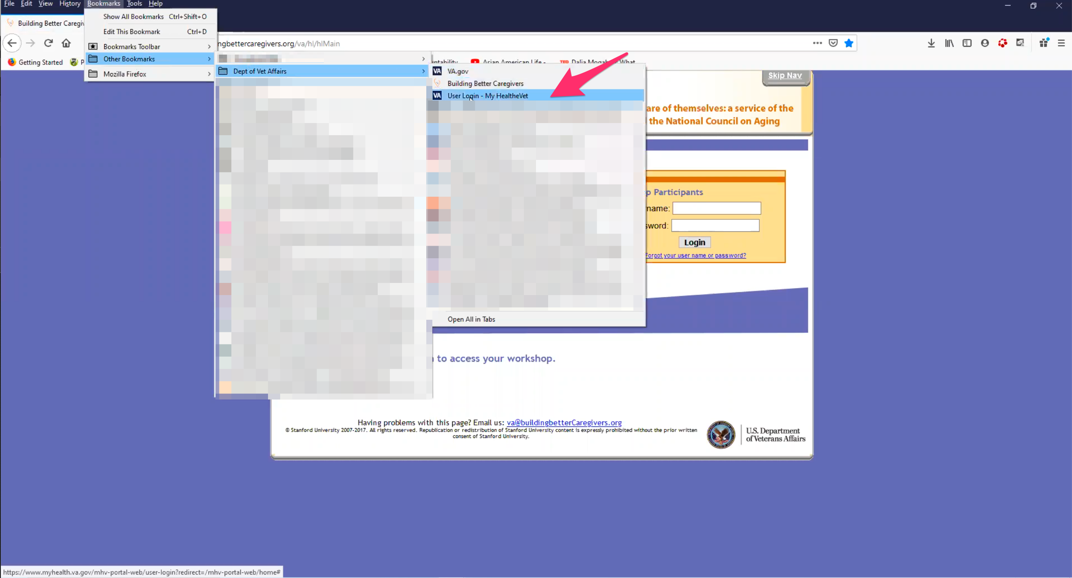

Participant has User Login page on My HealtheVet bookmarked in Firefox.

I have homeschooling [bookmarks], things for my mom, after the first of the year I will be her medical POW. Then they have had their car in and out of the shop for the last three weeks due to a branch falling on it. It is a mess. I finally had to tell my dad I was done. It is Christmas next week. I’m out three nights. I had to take something off my plate.

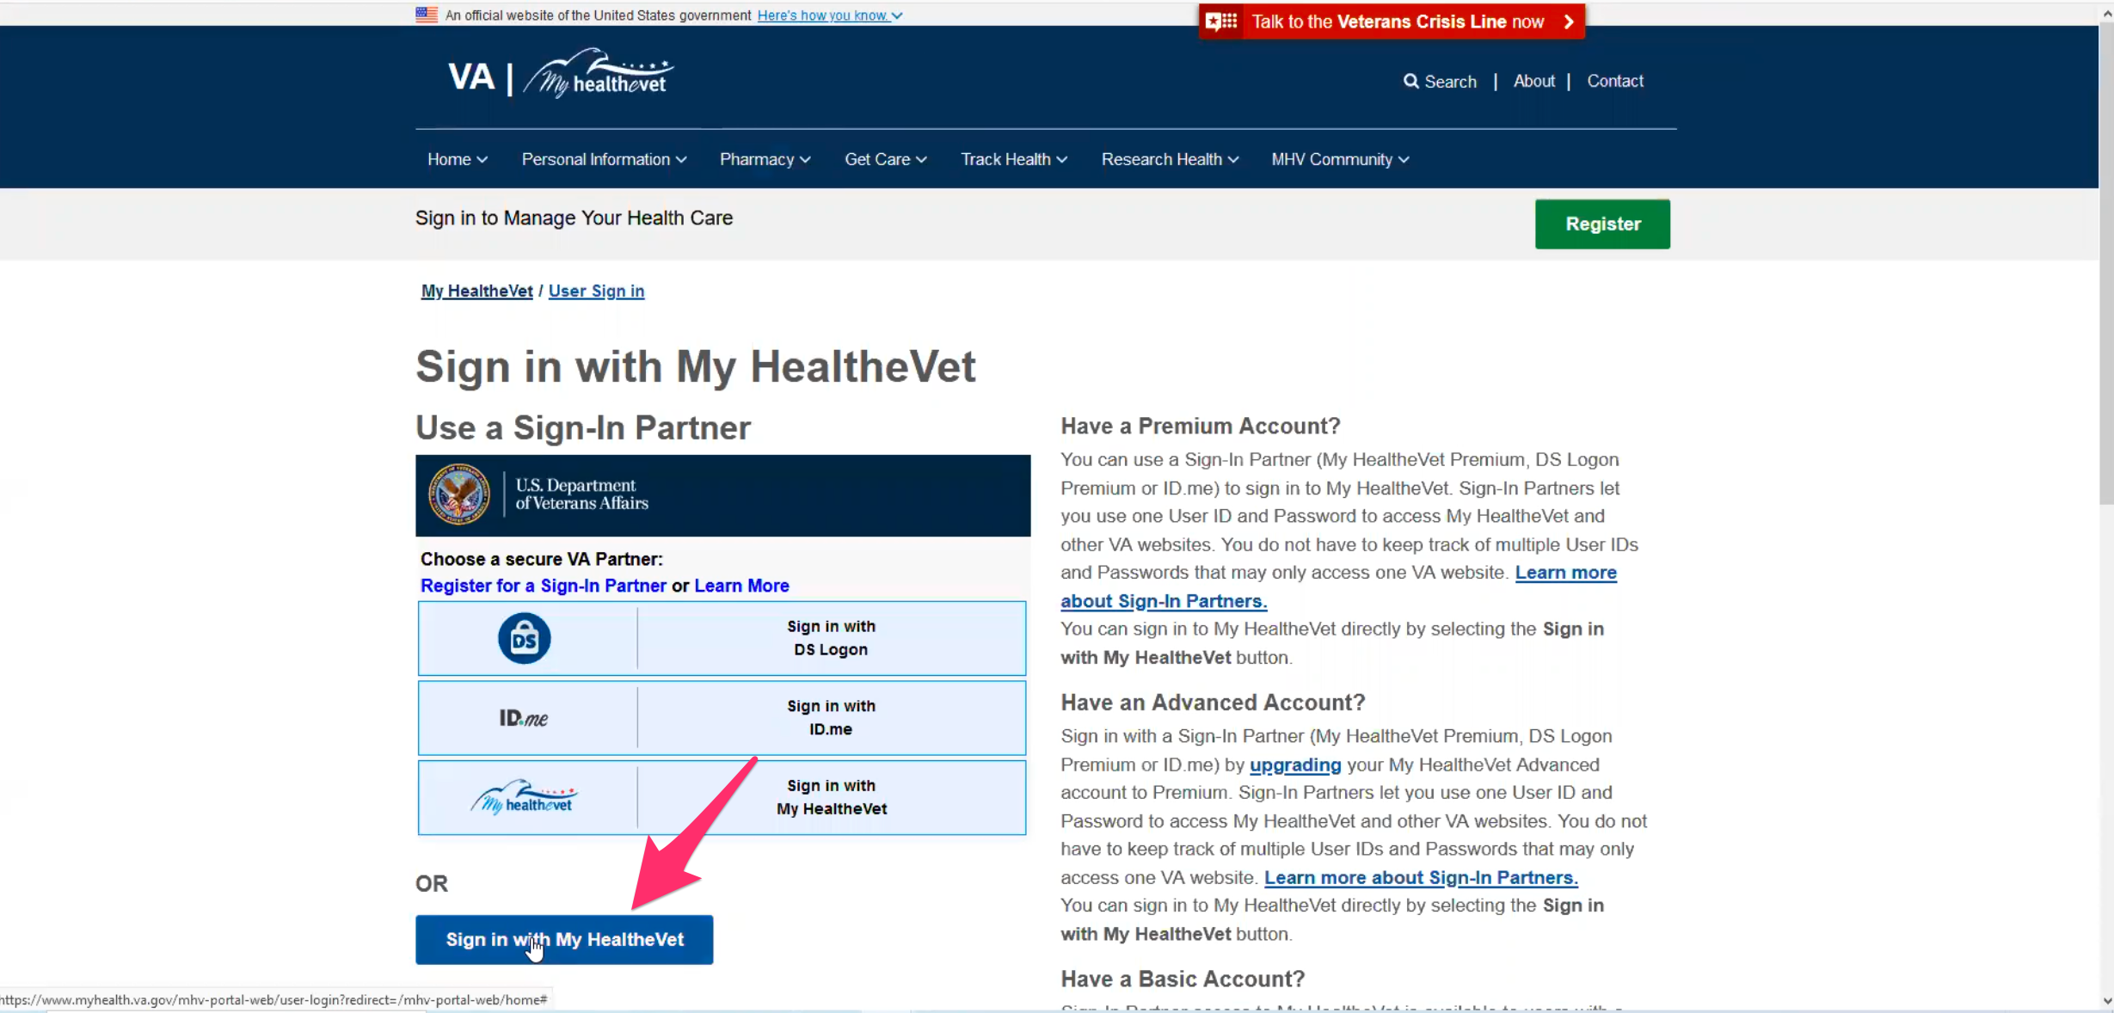

Participant clicks blue “Sign in with My HealtheVet” button.

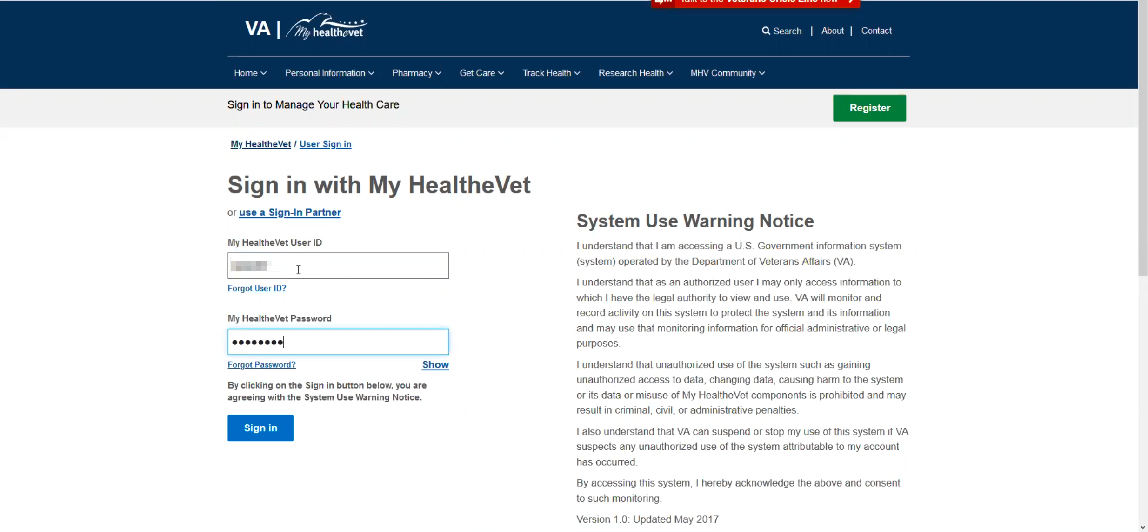

Participant hand types in User Id and password into form fields and clicks blue “Sign in” button.

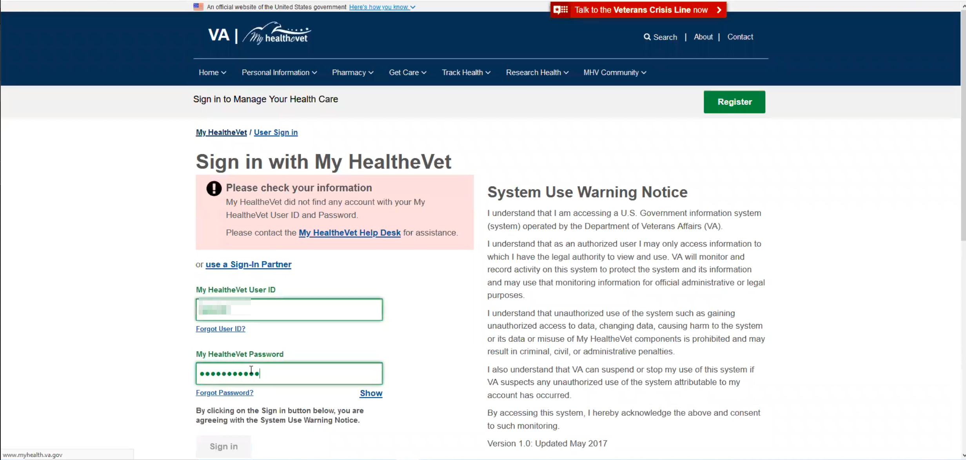

Participant’s password was incorrect. Again hand types in User Id and password into form fields.

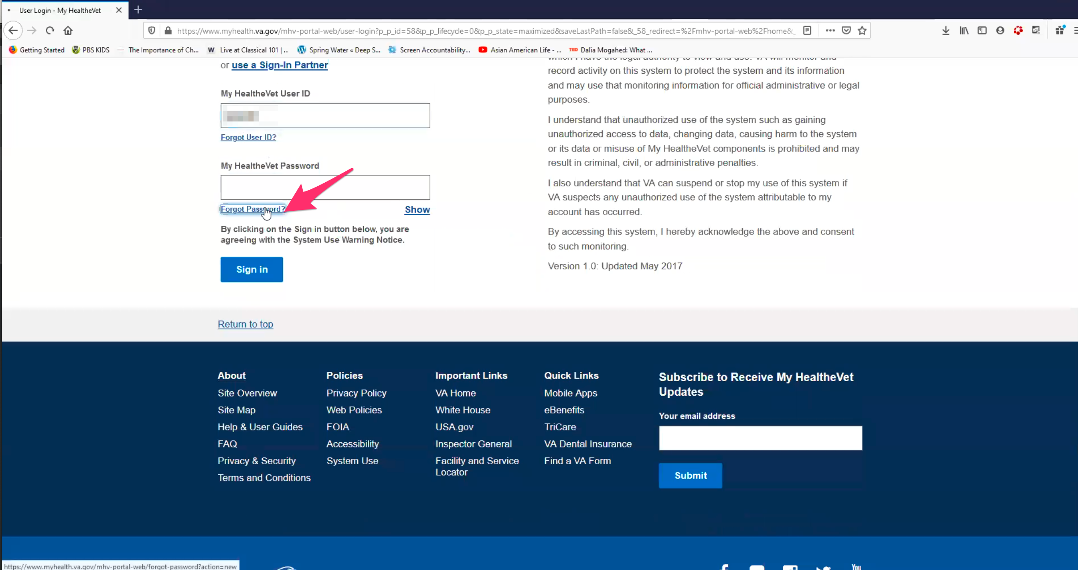

Participant’s password was incorrect a second time. Participant clicks on “Forgot Password” link.

You’re going to get to see how I reset my password.

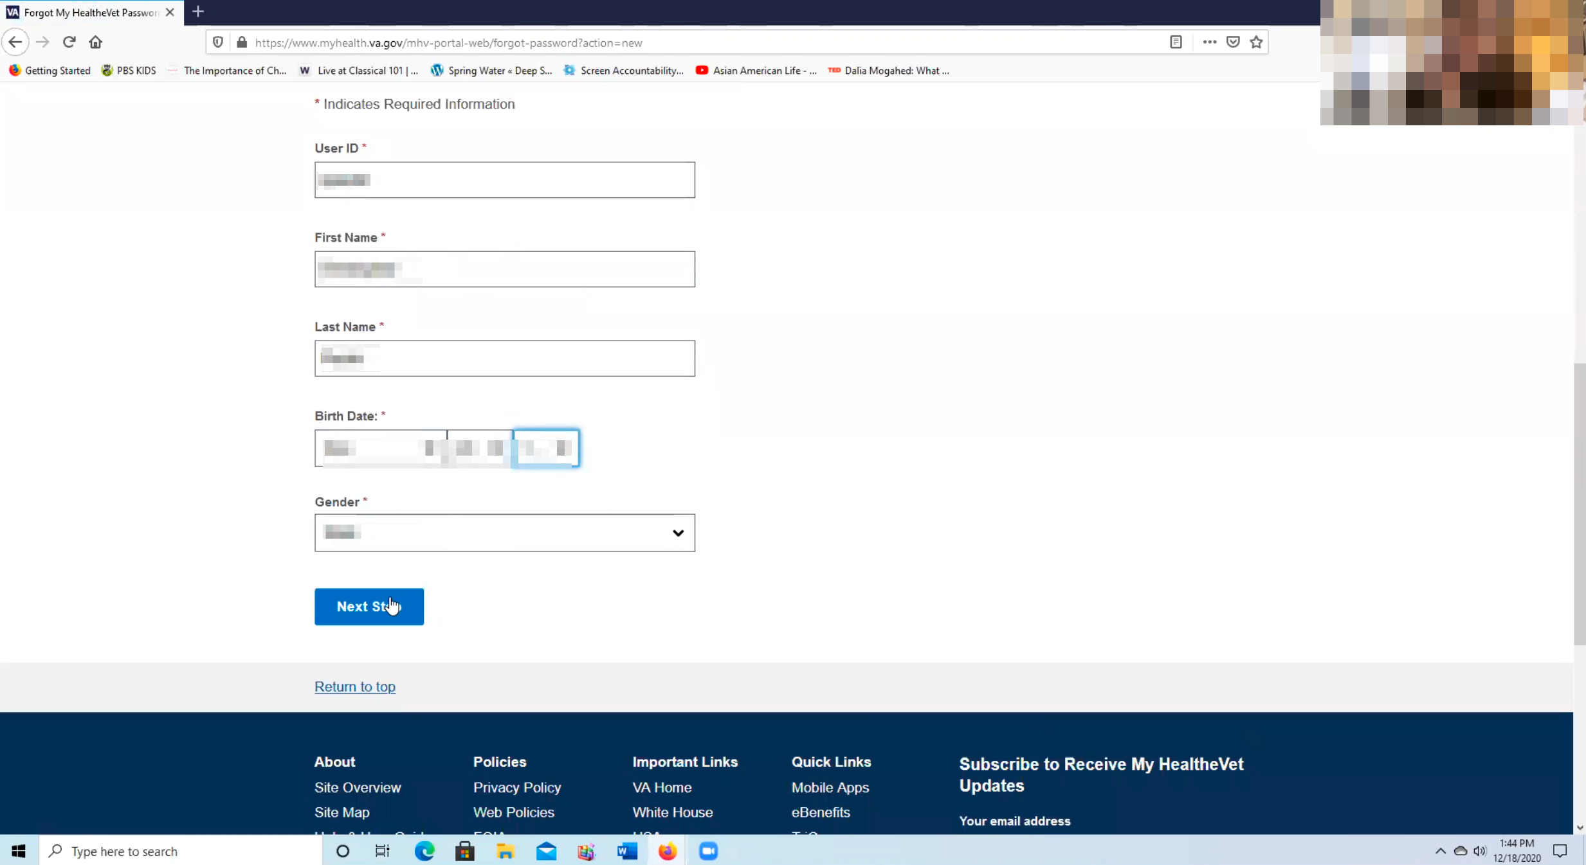

Participant fills out Step 1 of reset password form and clicks on blue “Next Step” button.

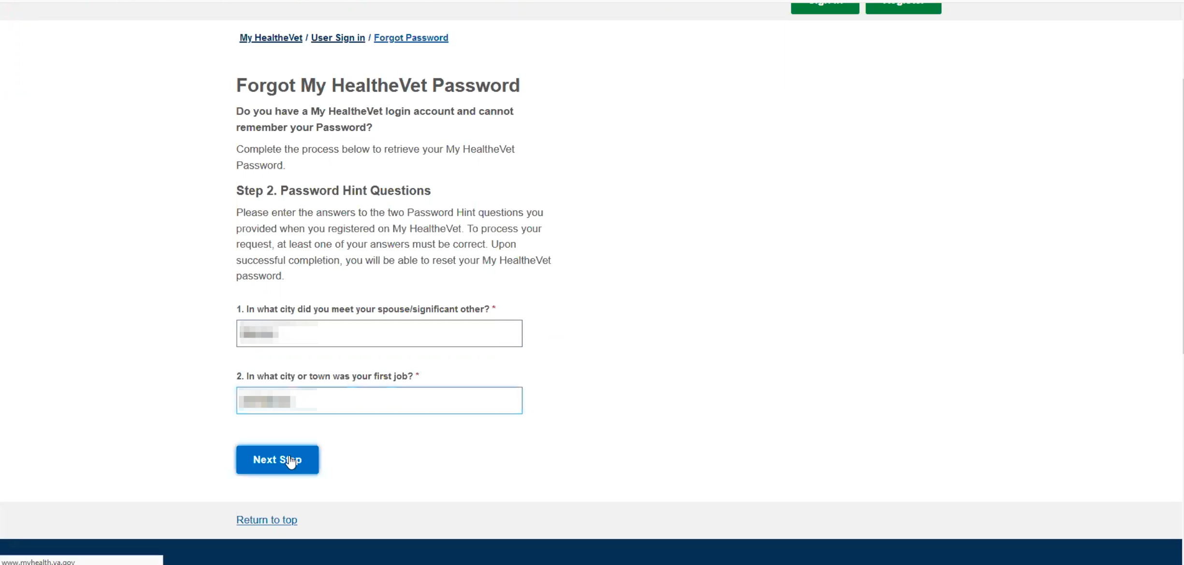

Participant fills out Step 2 of reset password form and clicks on blue “Next Step” button.

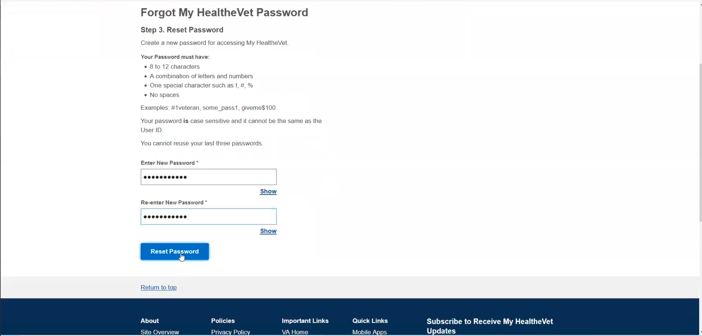

Participant fills out Step 3 of reset password form and clicks on blue “Reset Password” button. Noticed that Participant used Tab key to move between form fields.

**You use a desktop:**

Yes it is better to have the full keyboard. I have used it on the mobile device but I am not really sure how to use it on there and it is more stable on the computer.

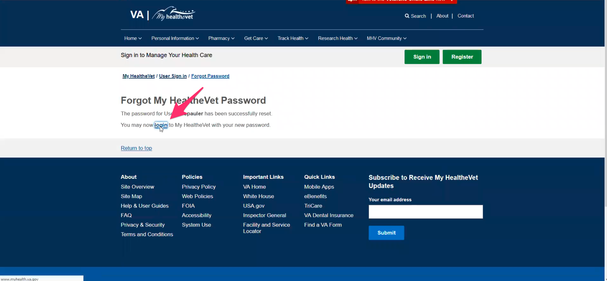

Participant clicks on “logon” link.

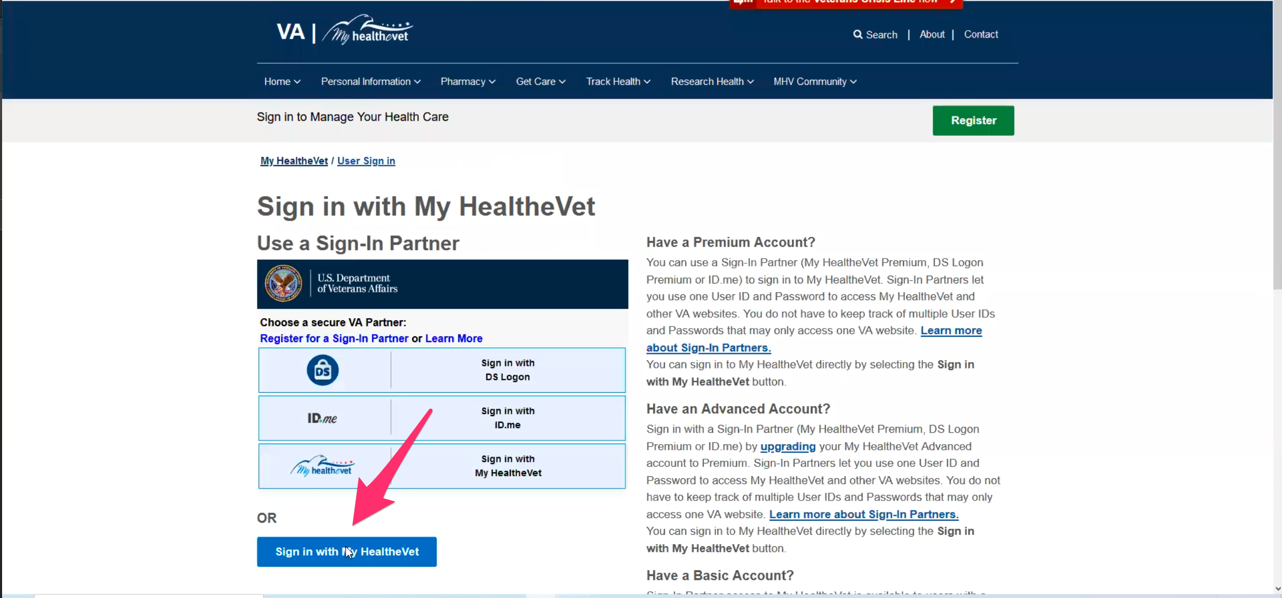

Sign in page loads and Participant clicks on blue “Sign in with My HealtheVet” button.

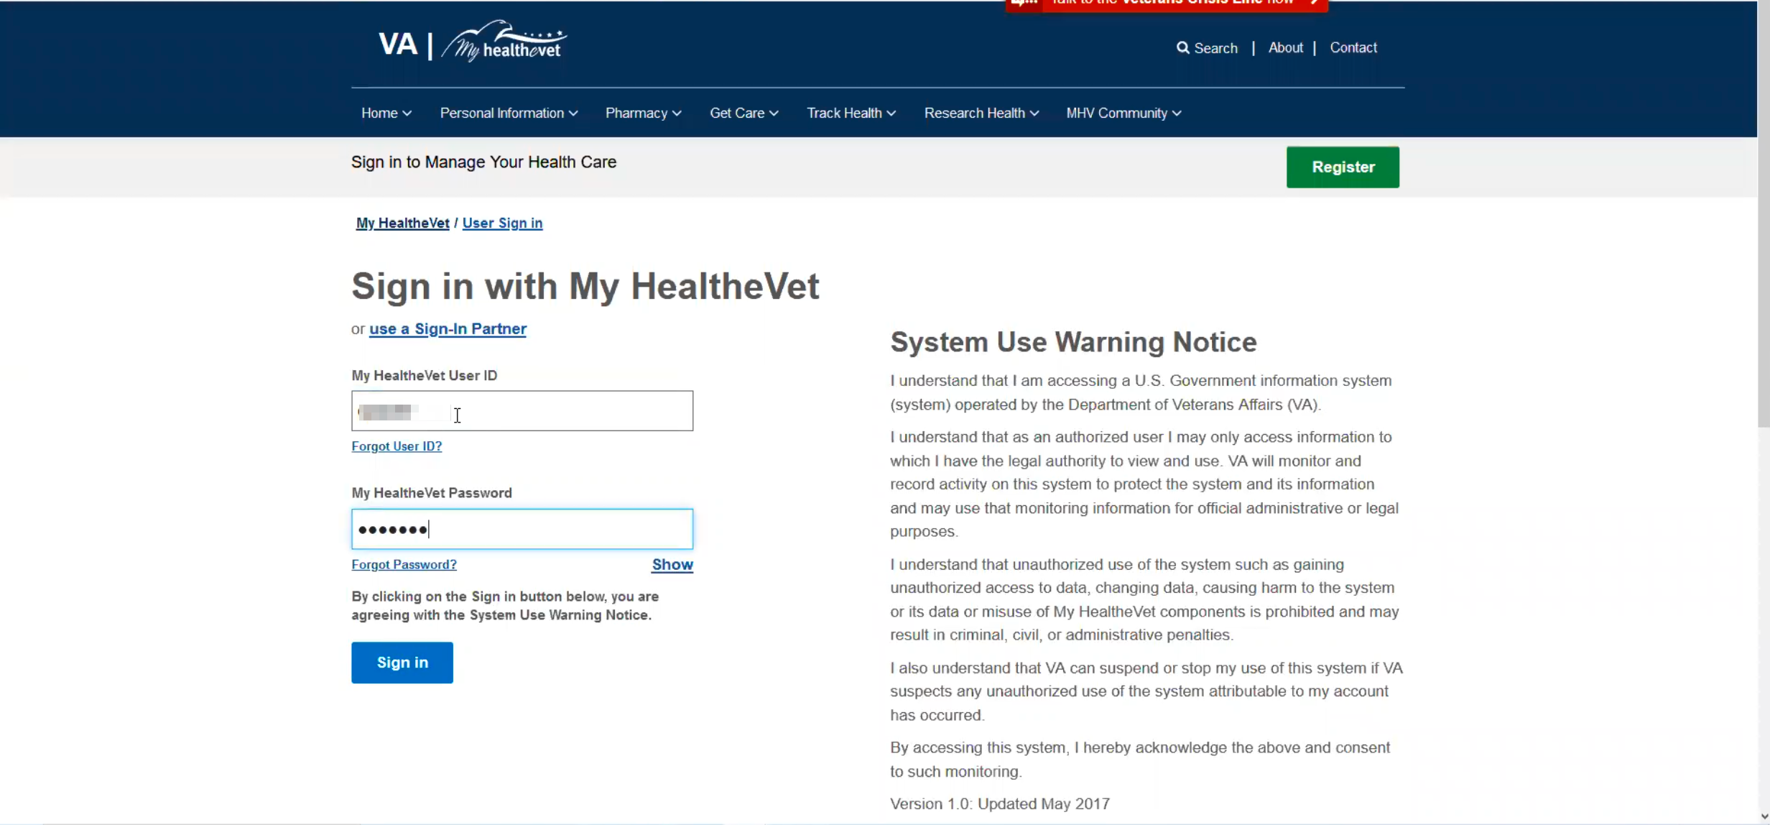

Participant hand types User Id and password into form and clicks blue “Sign in” button.

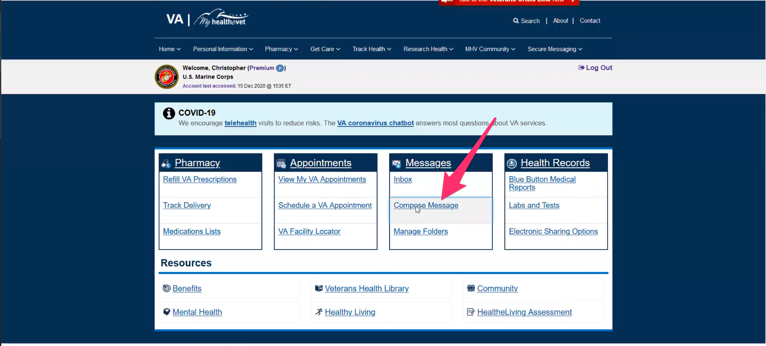

My HealtheVet home page loads. Participant immediately points out Messages box/callout and “Inbox” and “Compose Message” links. Participant clicks on “Compose Message” link.

So I go to inbox or right to compose message.

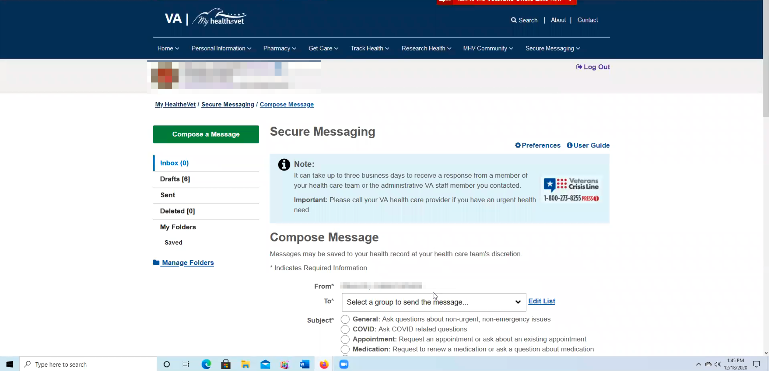

Secure Messaging page loads.

Then pick something from the drop down. *Participant is referring to the “To:” select form field on Compose Message form.*

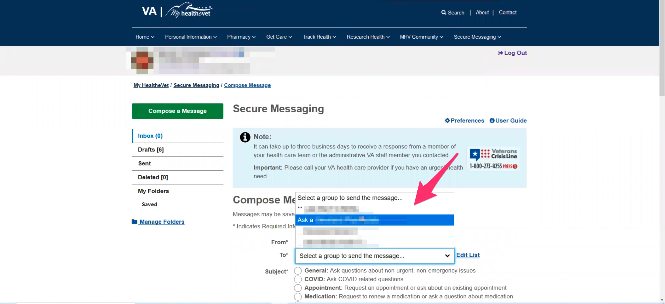

Participant points out the “To:” select form field on the Compose Message form.

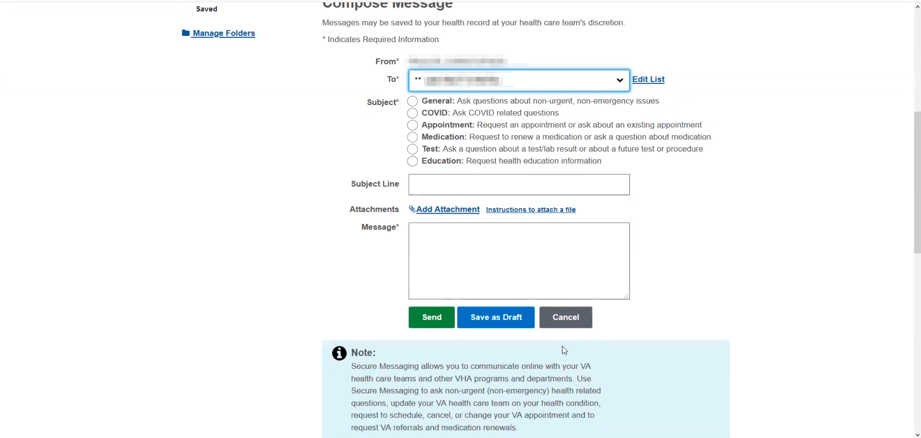

Participant scrolls down and points out “Message:” textarea form field.

Normally my messages for mental health will be longer. Especially these days have had family members causing issues. Who isn’t having this issue right now. Some people are asking how many people do I want at my holiday dinner. We’re asking do we want these people at our house right now. But they don’t want to understand the disability, or have their own mental health issues. Or just can’t live with out their instant coffee. I have heard it all this week.

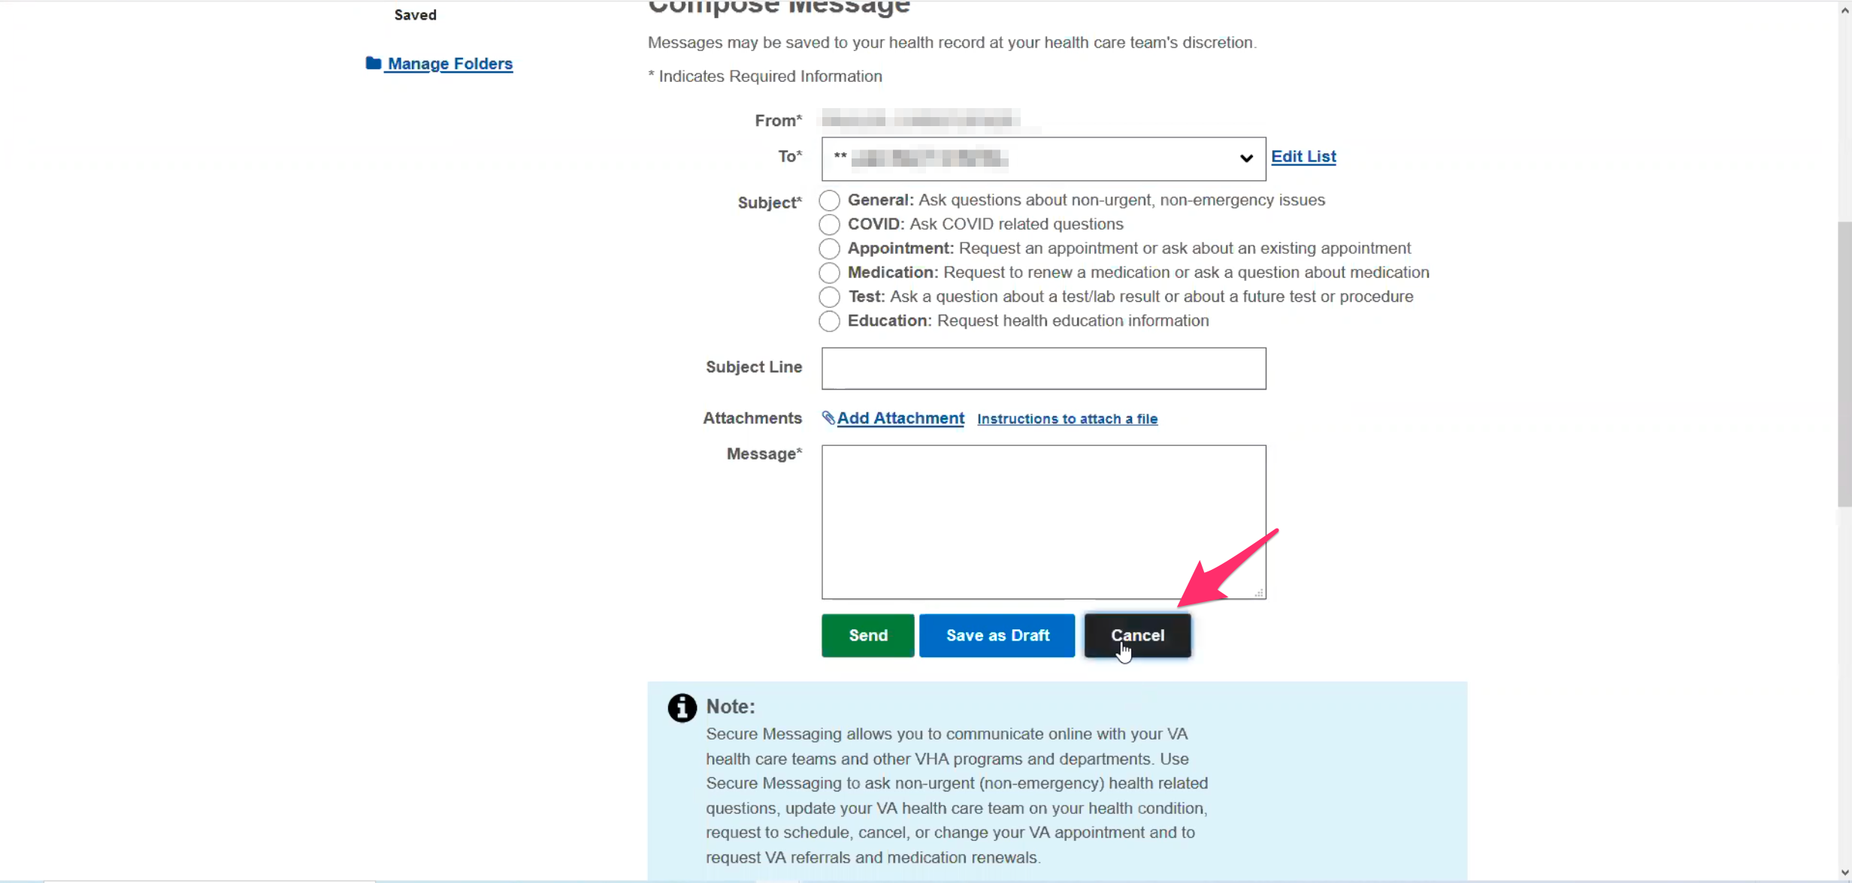

Participant clicks dark gray “Cancel” button.

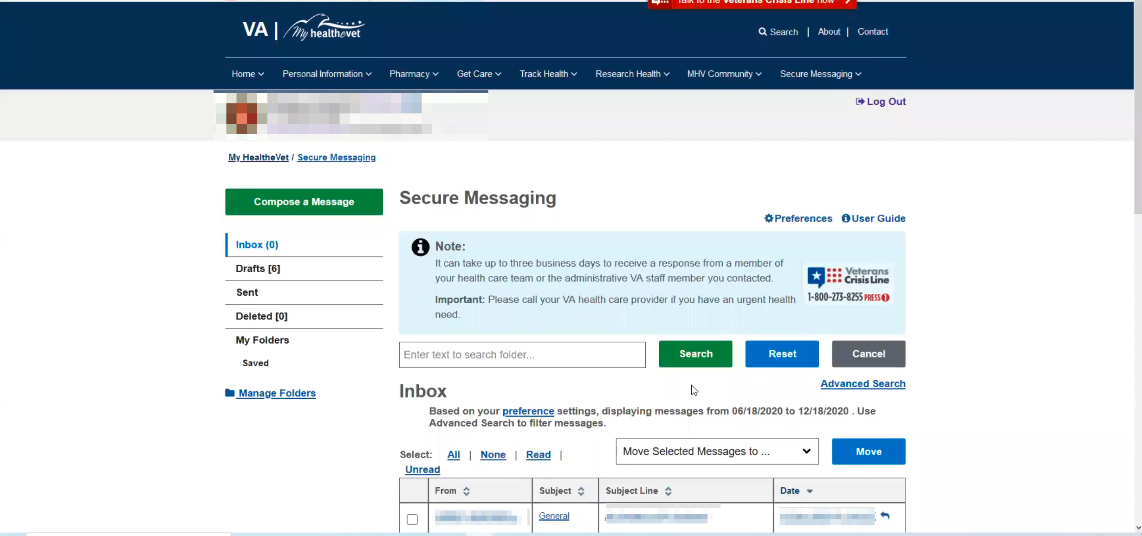

Secure Messaging page loads.

**When you are sending messages through MHV you indicate you are sending it:**

Yes, I normally put a sentence at the top that I am the primary caregiver and sign it as my name primary VA caregiver. I think they know caregivers would be using this more than the veteran.

**How do you know there’s a response:**

I normally get a notification to my email just so I know. I have it connected to my email instead of my husbands so I will know.

**Uses MHV about once a week:**

Yes

**What do you use it for the most at this point:**

To double check appointments and refilling prescriptions.

One is mental health medication, then one is toothpaste and then like a Flonase.

* **Do you want me to give any feedback on refiling prescriptions or appointments:**

Not in particular, no.

* **You mention that the travel pay was a challenge. Is there anything you want to show me about that online process:**

I found that they just instituted the BTSF the website. It’s usability is not so much with Firefox you need Chrome or Microsoft Edge it works the best in.

I definitely it is a multi-step process to log in because you have to profile review.

You have to add a visit then, and then you have to add a claim. If they could just combine them. Create a claim, put in the appointment information, and you click submit.

I would hope that when the backlog has been eliminated it would be faster. They said 5 day turnaround, maybe a little while longer. And like I said it took 5 months.

**Which website was that you use for travel:**

I can show you.

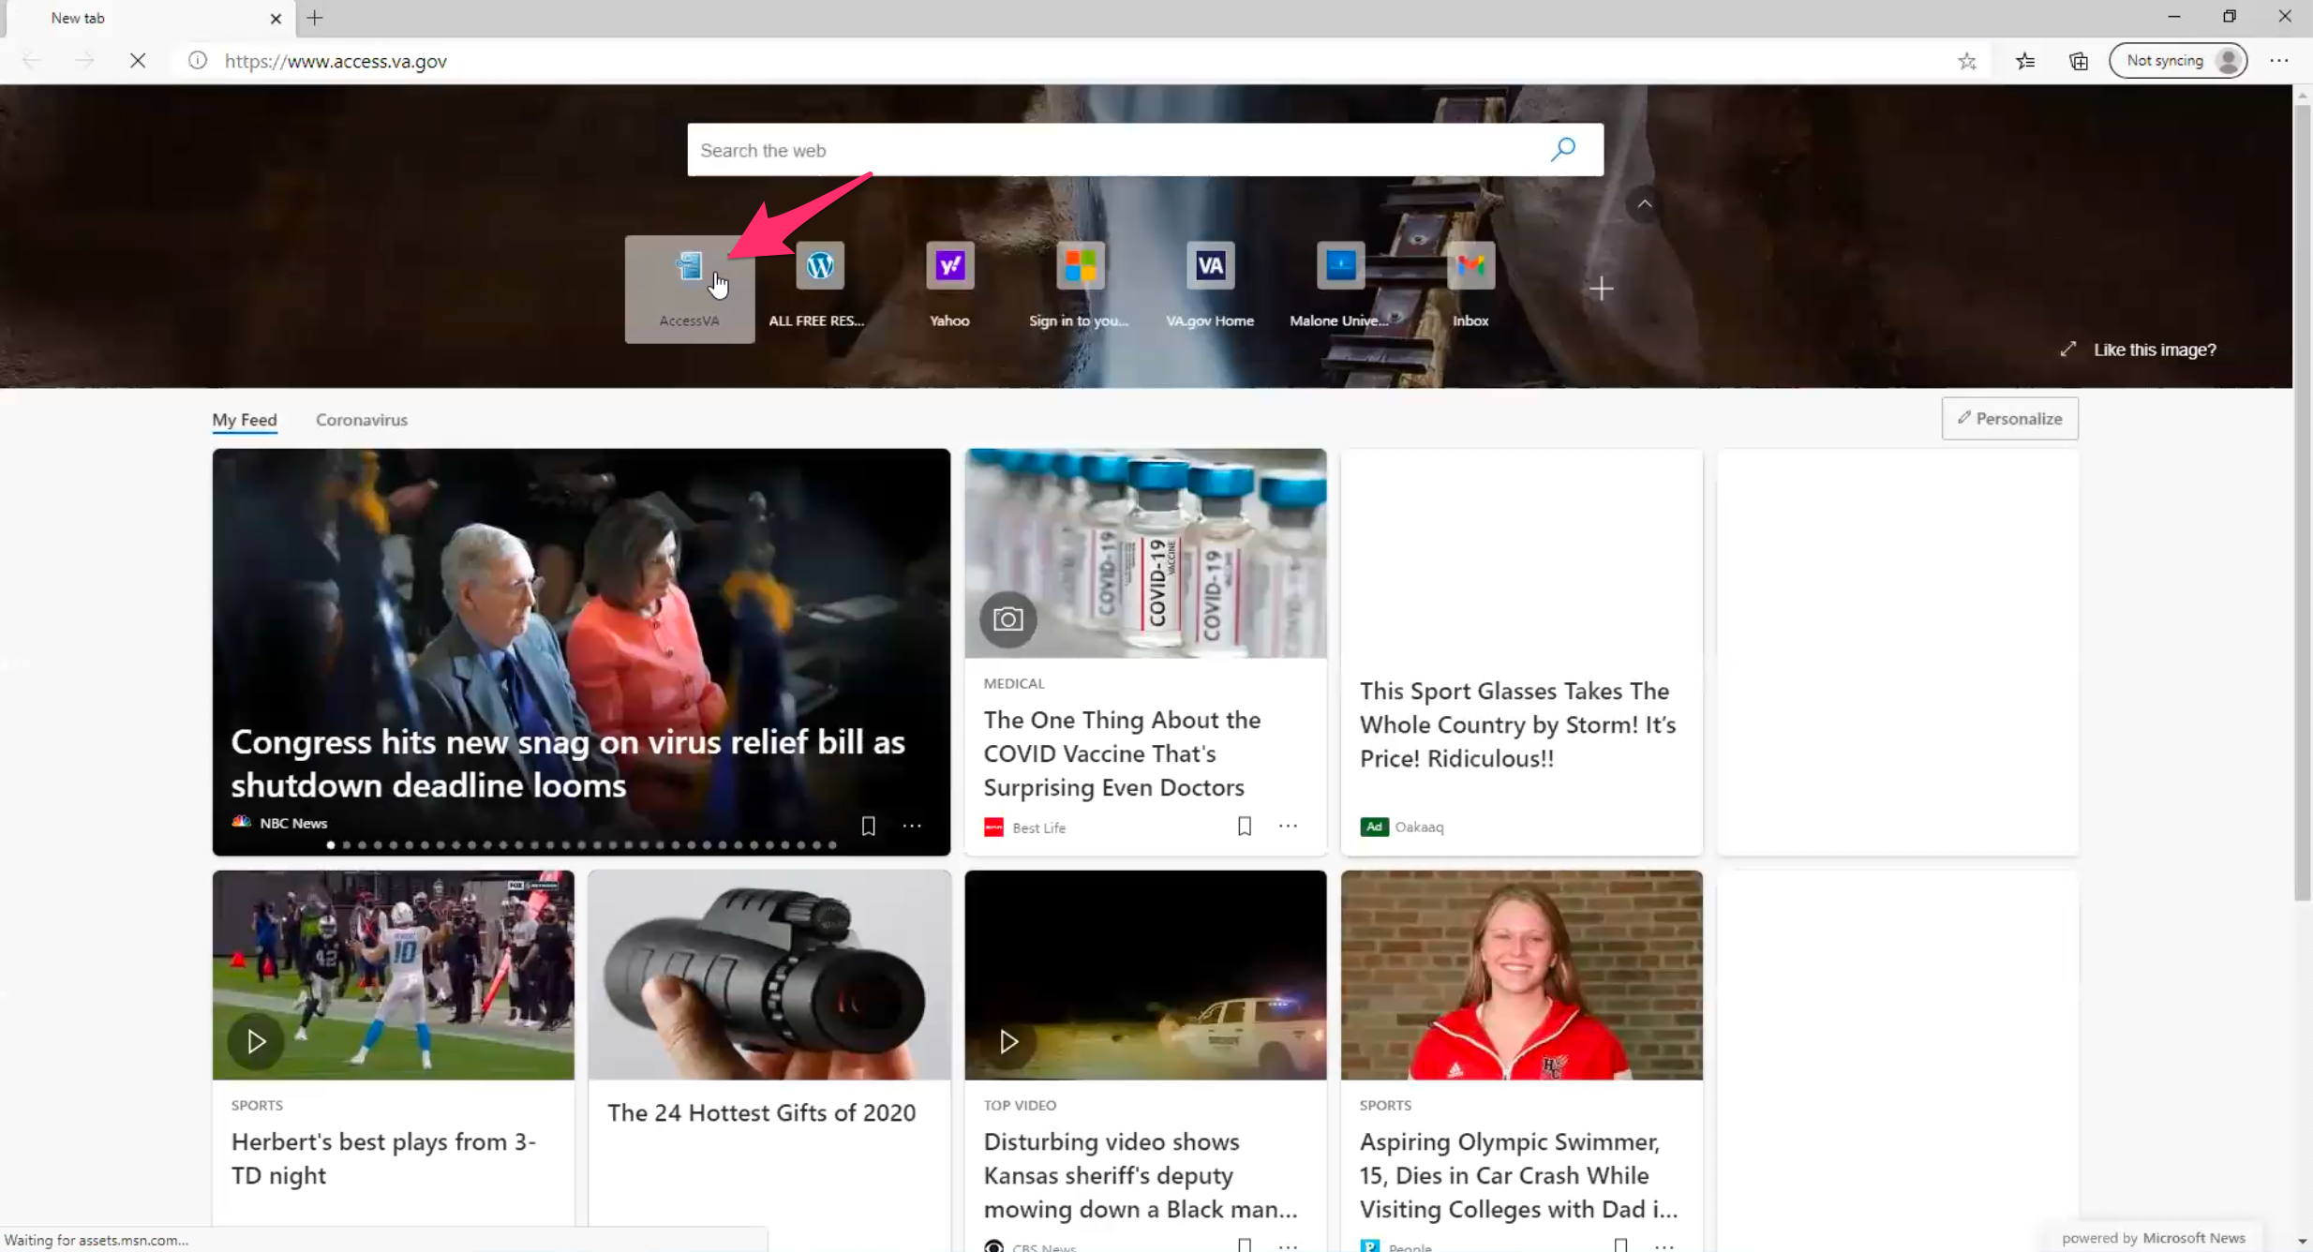

Participant opens Edge browser. AccessVA comes up as most frequented on start page. Participant clicks link.

Access VA. Then you go to family member travel pay and then login.

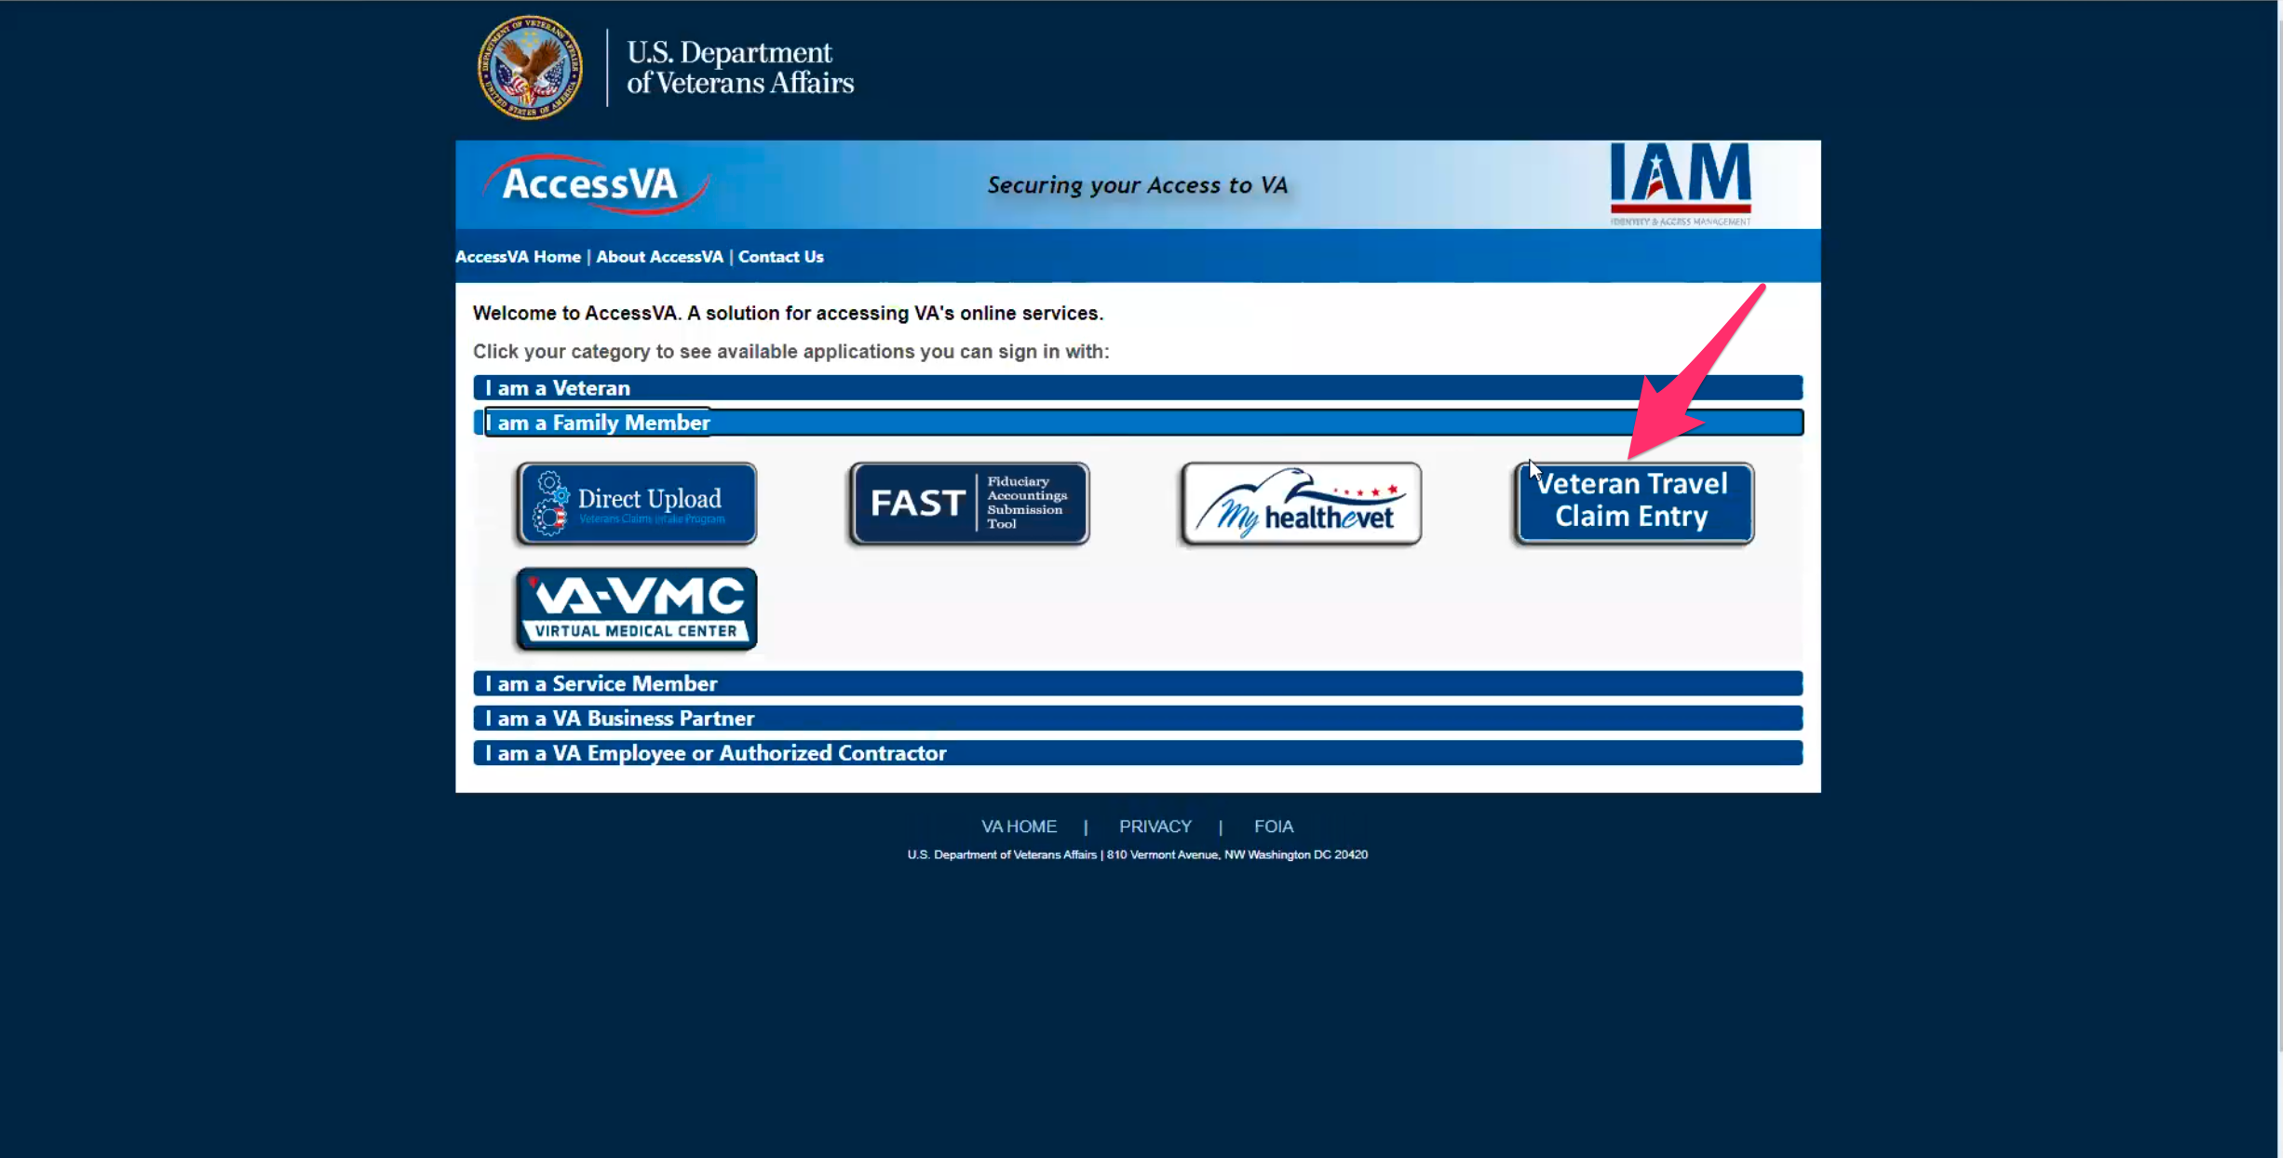

AccessVA page load. Participant clicks on “I am a Family Member” to open accordion, and the clicks on “Veteran Travel Claim Entry” image/link.

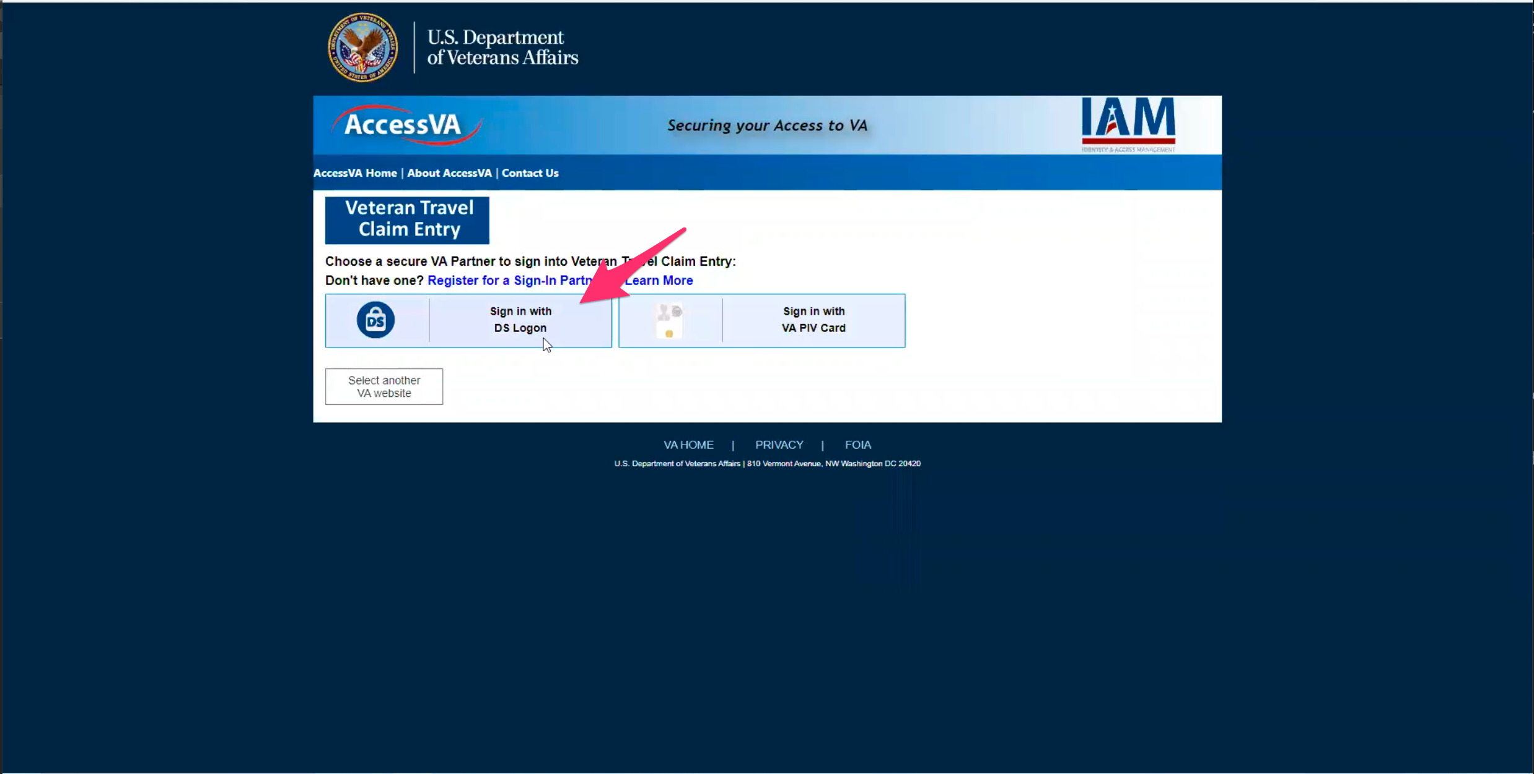

Veteran Travel Claim Entry sign in page opens. Participant immediately clicks on “Sign in with DS Logon”.

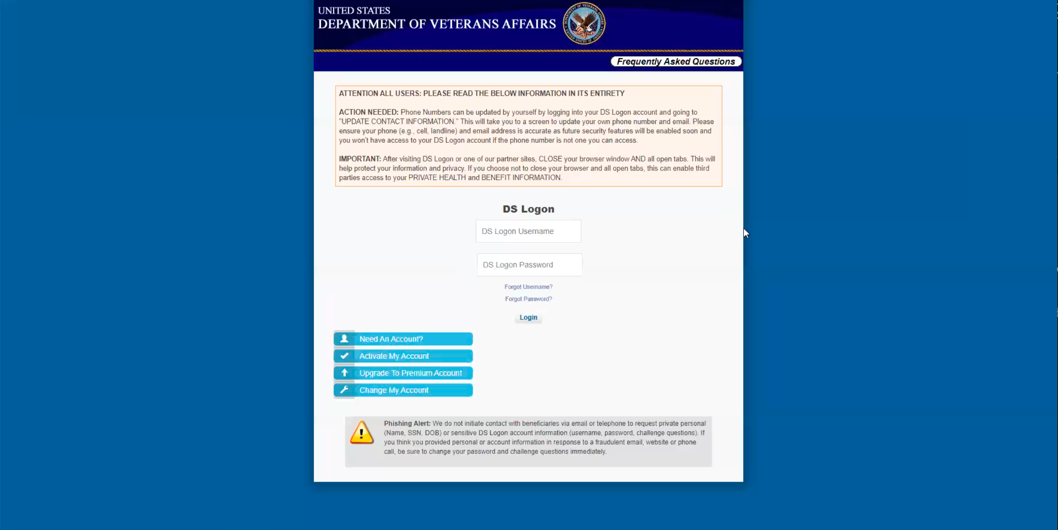

DS Logon page loads.

And then I will put mine ine. I have an Ebenefits account. It’s for mostly for information for my VA education benefits, like for a certificate of eligibility if I am changing programs. My use is very limited, like if we need a letter. and it is on his account.

**For your Ebenefits account are those education benefits from husband:**

They are chapter 35 dependent education assistance. Basically he is my sponsor. By the time I was ready to do a degree it had to be chapter 35 because he used his post-911 GI bill for his Associate of Art.

It was for a good sense of accomplishment and gave him something to focus on.

* **You mentioned that use** va.gov **for certain things**:

Yes, for forms or look at a particular program. Mostly for information. I think for caregivers they have a toolbox like meditation and they do monthly calls for caregivers. I hardly ever use it. I think the last call I listened to was in March or April. I have not had the time understandably.

**Branding and trust (5 minutes)**

Now I’d like to ask for your thoughts on My HealtheVet. (Confirm that participant has used My HealtheVet previously. If not, amend questions below to capture their first impressions while looking at a logged in account.)

1. **How would you describe My HealtheVet to a fellow caregiver?**

I would say it is a one stop shop to managing your healthcare. For updating information. You can get information for certain conditions under Research Health.

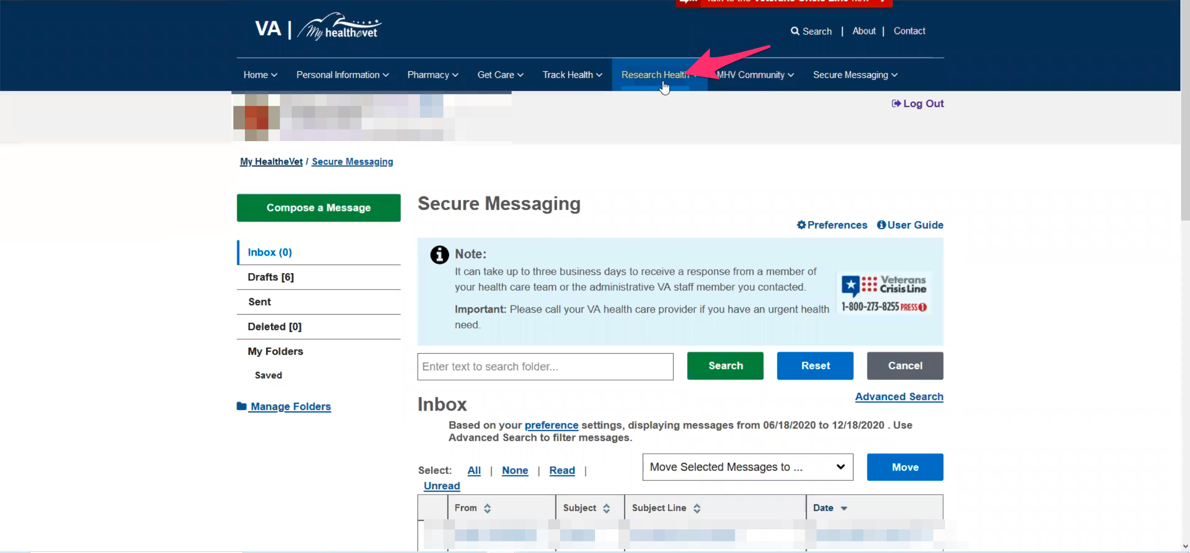

Participant hovers over “Research Health” in My HealtheVet website main navigation.

Hopefully schedule appointments.

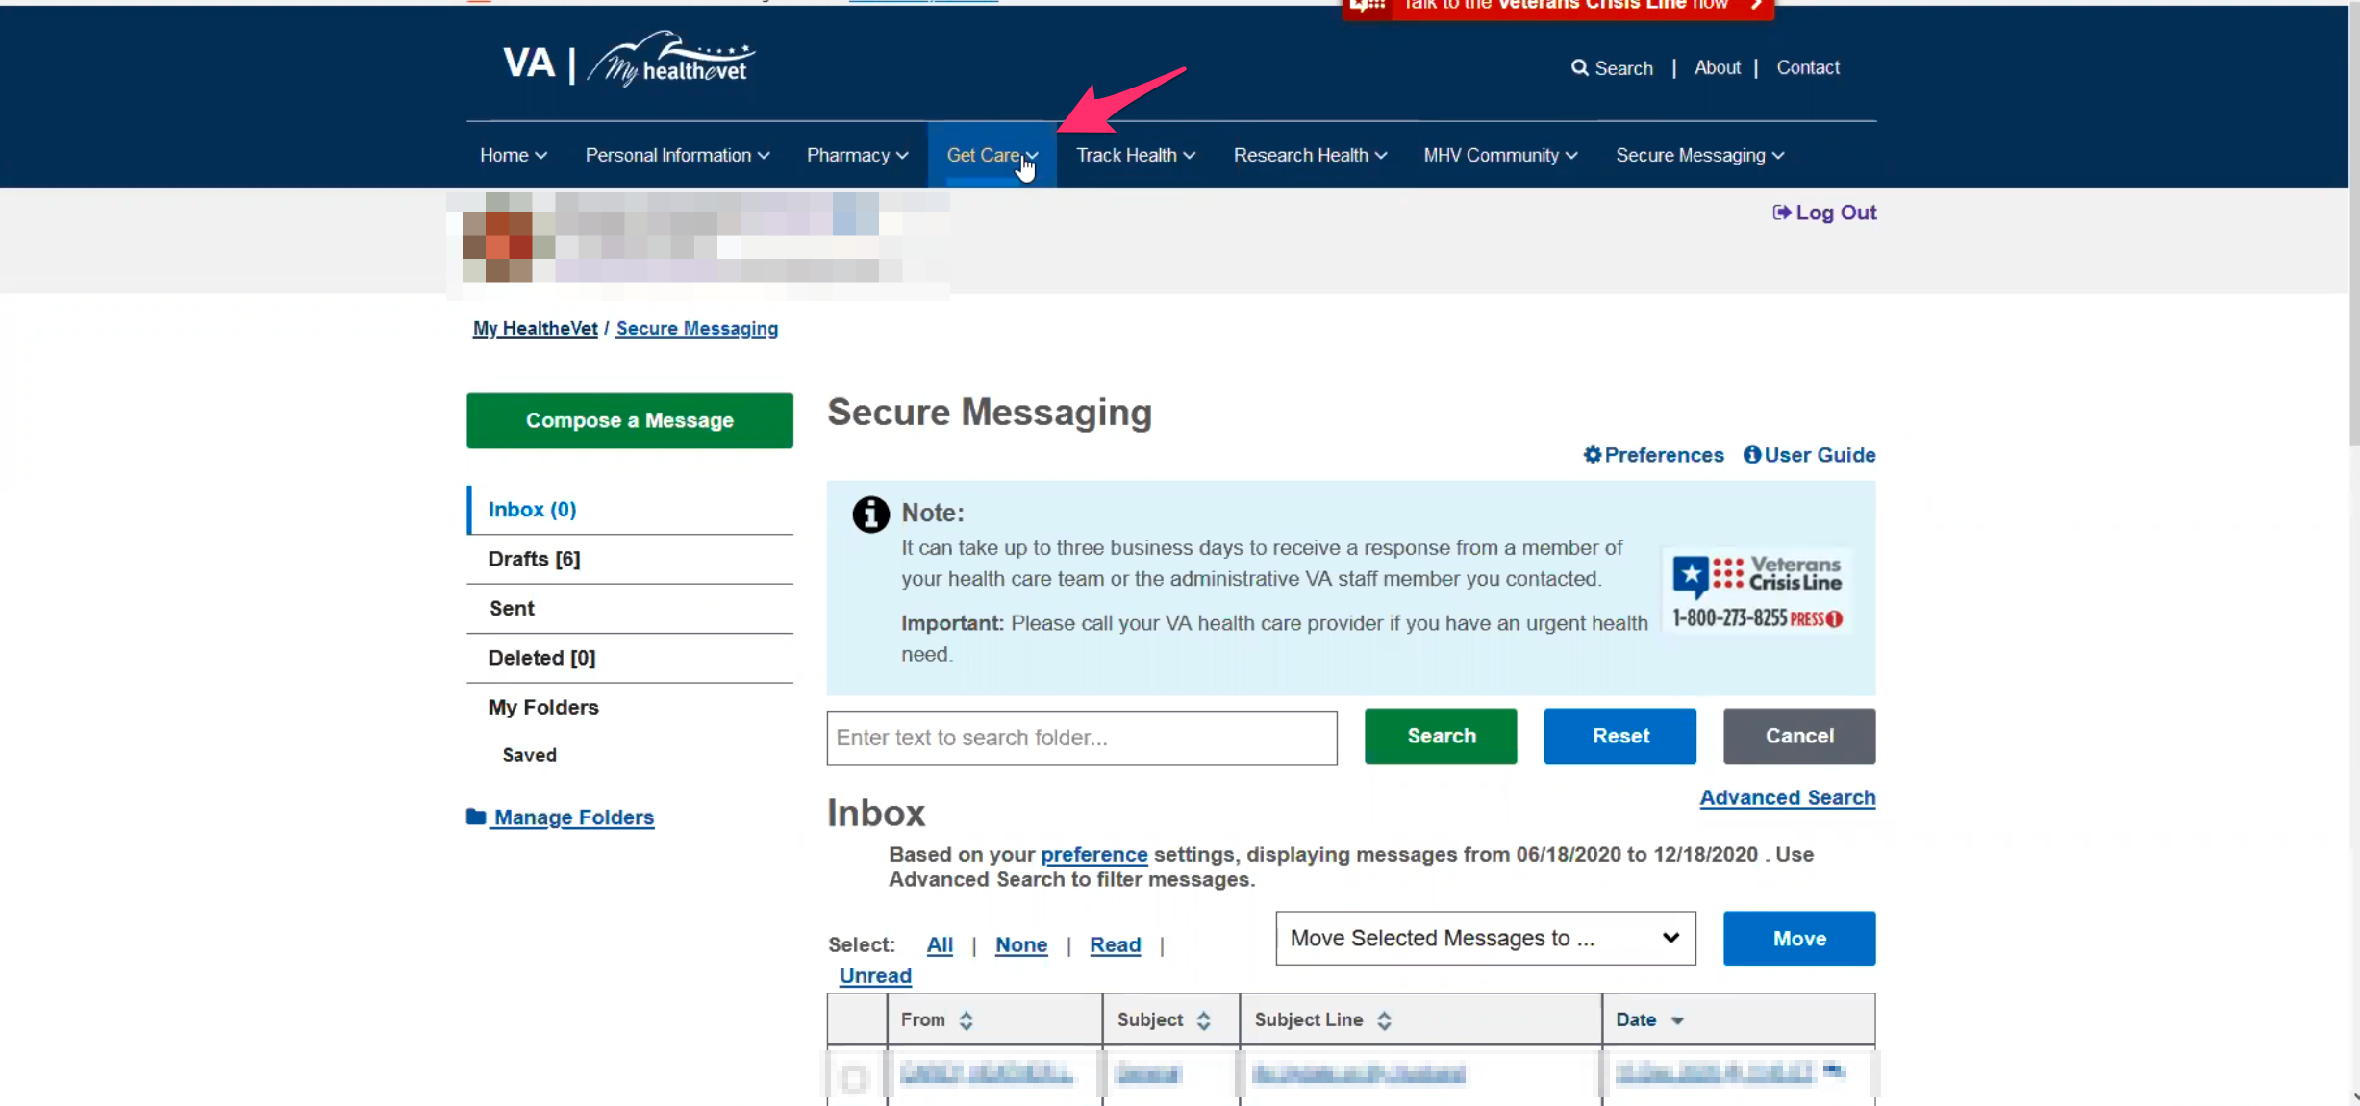

Participant hovers over “Get Care” in My HealtheVet website main navigation.

It is easier and more versatile than to get on a call to ask questions or schedule. Sometimes you don’t have 30 minutes to wait on hold, you can use this if you need to. For something that’s maybe not urgent.

1. **What about “VA health care”. How would you describe that to a new caregiver:**

I would say it is something you want to get comfortable using as quickly as possible. At the very least get a primary care as soon as possible. If you’re a women and you need OBGYN care. I think it’s good. It allows you to centralize your healthcare too.

1. **On a scale from 1-5, with 1 being very dissatisfied, and 5 being very satisfied, how satisfied are you with My HealtheVet?**

I would say a 5.

**3.a. What makes it a 5:**

Just the ease of using it. The fact that there are hardly any down time for the site. Sometimes there is scheduled maintenance but it is when people are sleeping or supposed to be asleep.

1. **On a scale from 1-5, with 1 being very low, and 5 being very high, how would you rate your trust in My HealtheVet?**

I would say a 4.

**4.a. What makes you rate it a 4?**

It is not always the best avenue to seek care, it’s not their fault. It is just that some things you just need an in-person or telephone conversation about things.

**My HealtheVet patient portal (15 minutes)**

Let's take a look at My HealtheVet together.

Moderator will ask participant to share screen if not already, or show logged in My HealtheVet account. **(5 minutes)**

1. **What do you wish this website did that it doesn’t do right now?**

I would say as soon as possible more medical centers getting on board with the scheduling appointments online. To me it would reduce call flow, it makes it easier for the caregivers. Most of us have internet and a tablet. It makes our life easier.

**You’ve run into issues where you can’t schedule online due to area:**

Yeah, and there are bugs. I that know scheduling online is still fairly new.

**Do you remember and particular bugs:**

Not really. I haven’t been running into them lately. Sometimes just calling then the holding. Especially now you may have two people in one office handling the call volume of thousands being added to the caregivers core program. Not to mention those getting out and transitioning.

1. **Have you ever looked under health records or used any of those options to see your husbands health records:**

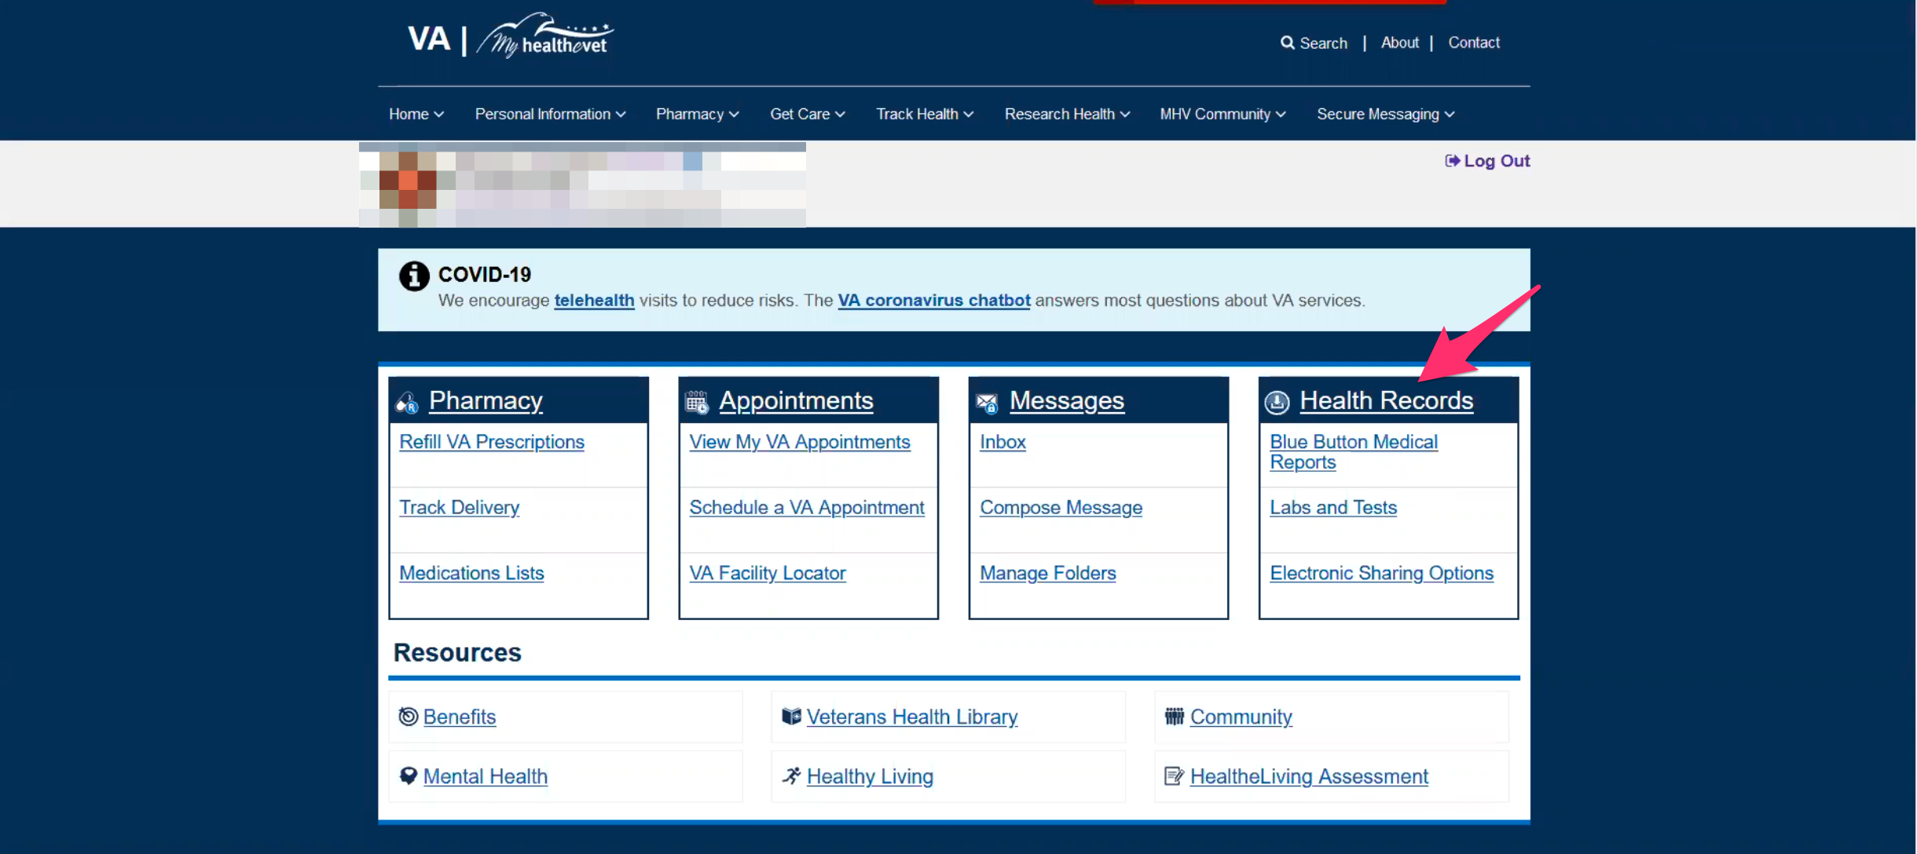

Participant is on My HealtheVet home page. Moderator is talking about Health Records box/callout.

Yes, the labs and tests when he has an appointment. I tend to print off the tests so he can look at them and take them when going over them with him his provider. It is once every 6 months it is usually fairly easy.

**In terms of his entire health record is that something you’ve looked for on here:**

No, I haven’t had to. At one point I had them send everything that could be released onto a few CD’s and they are kept in a secure location. Thats progress notes, everything.

**Doctors notes:**

Yes. They put everything on the CD.

**Thank you and closing (2 minutes)**

**Feedback:** I think we covered everything and as much as we can.